CONFIDENTIAL CS/OCT 2026/MAT133

UNIVERSITI TEKNOLOGI MARA FINAL EXAMINATION

COURSE
COURSE CODE
EXAMINATION TIME
PRE CALCULUS
MAT133 OCTOBER 2026
2 HOURS

INSTRUCTIONS TO CANDIDATES

- This question paper consists of 5 questions.

- Answer ALL questions in the Answer Booklet. Start each answer on a new page.

- Do not bring any material into the examination room unless permission is given by the invigilator .
- Please check to make sure that this examination pack consists of: i) the Question Paper
  - a one - page Append ix 1
  - an Answer Booklet - provided by the Faculty
  - a graph paper - provided by the Faculty

- Answer ALL questions in English.

/

DO NOT TURN THIS PAGE UNTIL YOU ARE TOLD TO DO SO

This examination paper consists of 7 printed pages

QUESTION 1
a) Solve the inequality 2x² - 4x - 16 ≤ 0.
(5 marks)
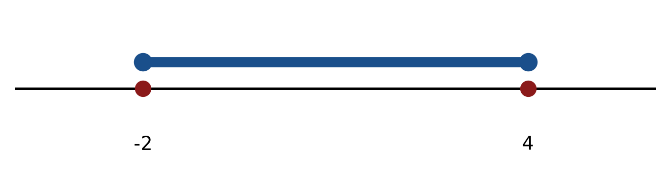
Figure: critical values.
b) Solve the inequality |-4x - 2| ≥ 8. Express the answer in interval notation and on a number line.
(5 marks)
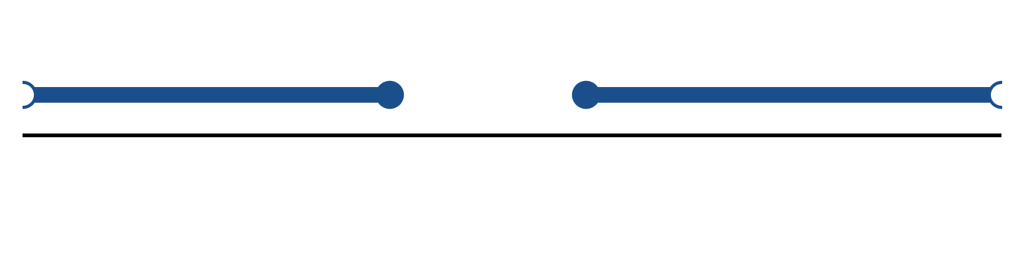
Figure: solution on a number line.
c) Sketch y = 2|x + 2| - 2. State the vertex, the y-intercept and any x-intercepts.
(5 marks)
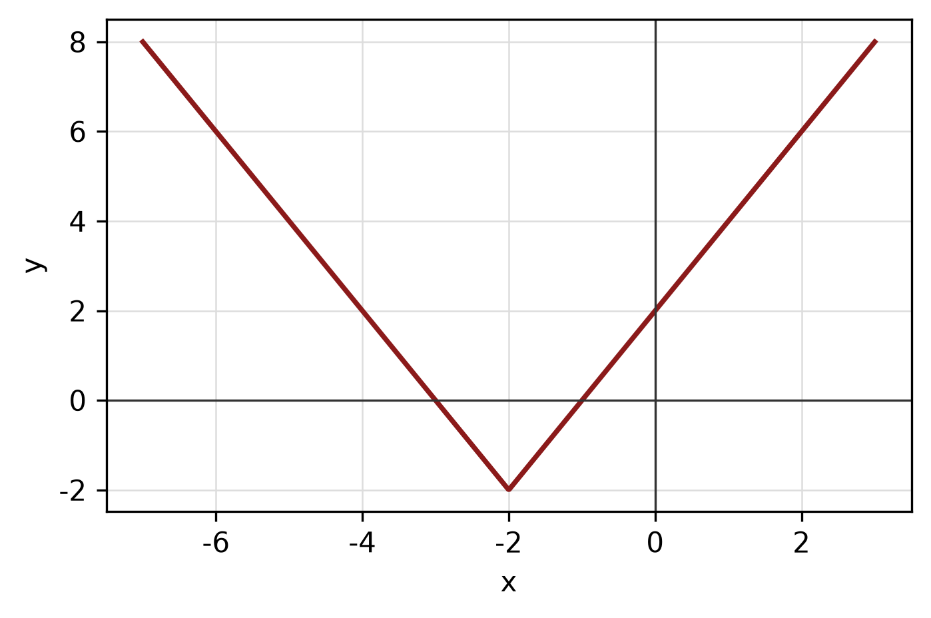
Figure: absolute-value graph.
QUESTION 2
a) The piecewise function is defined by
f(x) = 3 - x, if x < -1;
f(x) = -2, if -1 ≤ x ≤ 2;
f(x) = x² - 1, if x > 2.
Sketch the graph and find f(-2), f(0) and f(3).
(5 marks)
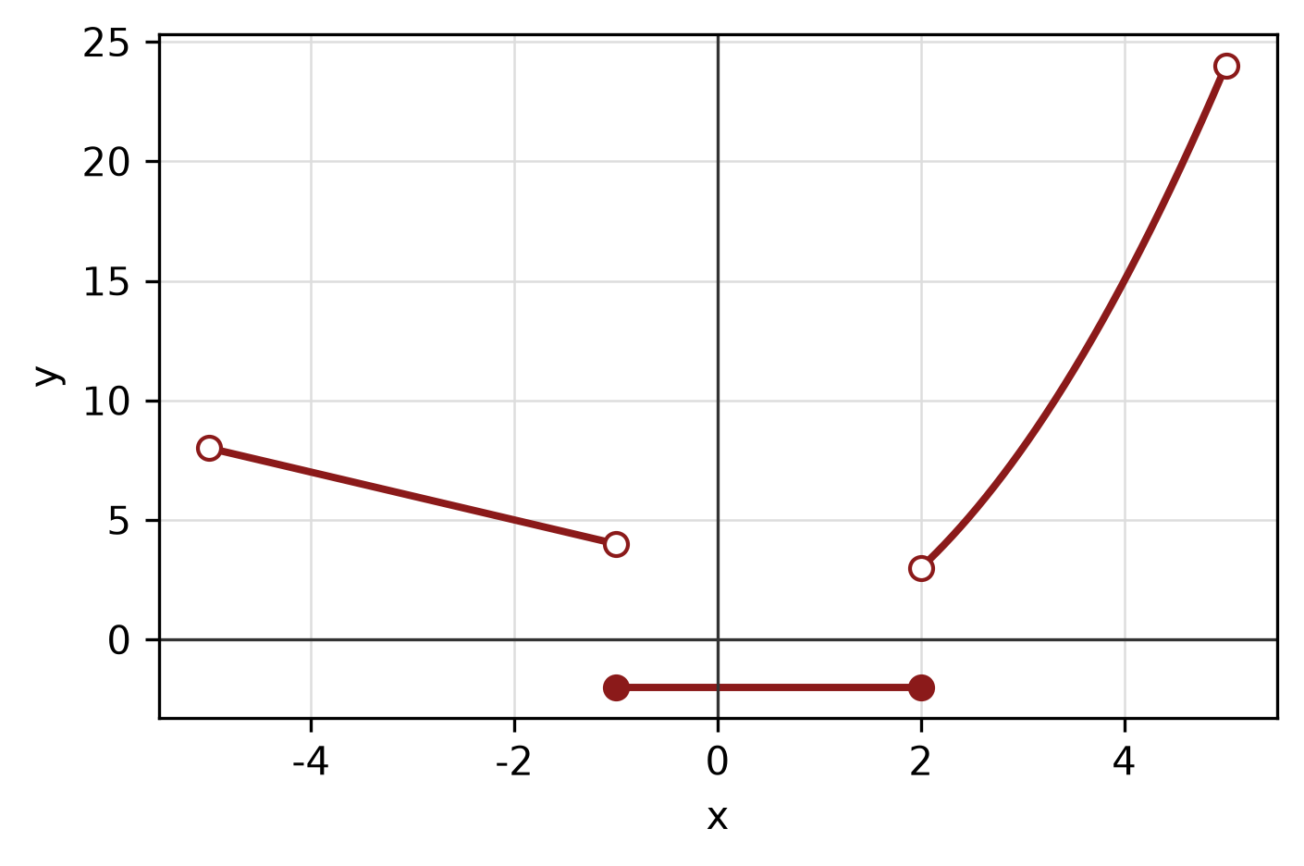
Figure: piecewise graph.
b) Sketch y = |x - 2| + 1 for -2 ≤ x ≤ 6. State the domain and range.
(4 marks)
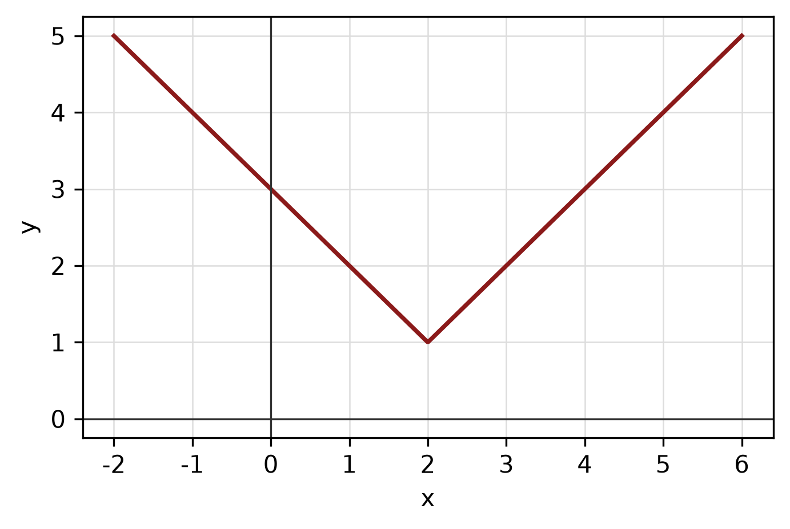
Figure: function graph.
c) The endpoints of a diameter of a circle are (4, 4) and (7, 4). Find the centre, radius and equation of the circle.
(5 marks)
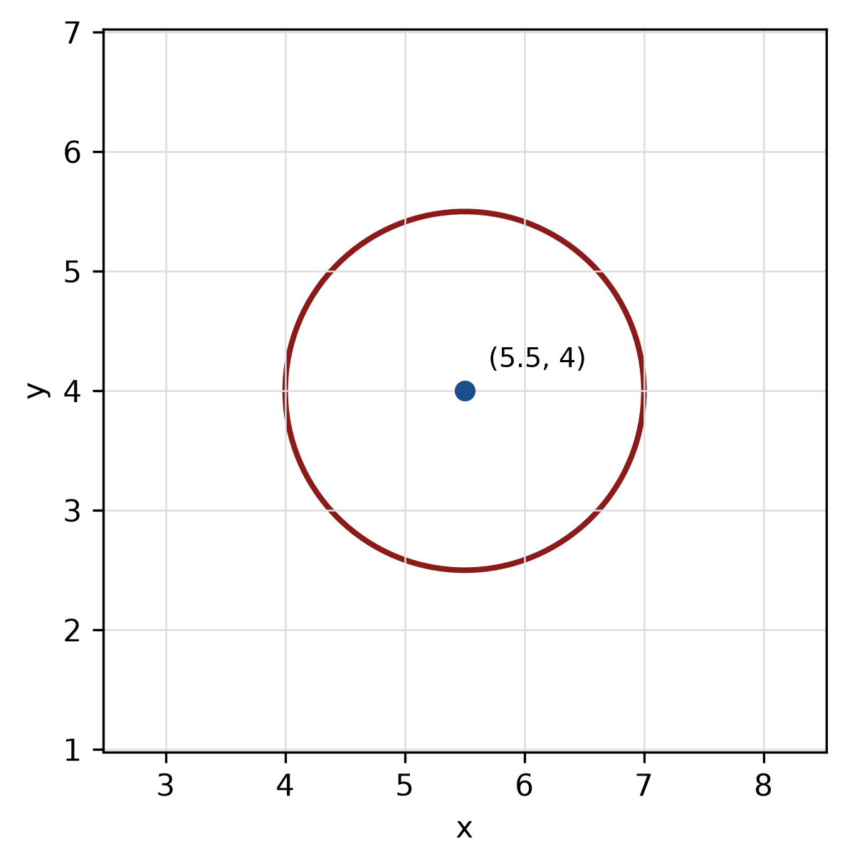
Figure: circle from diameter.
QUESTION 3
a) Given z₁ = 4 - 4i and z₂ = 2 - 5i, express z₁/z₂ in the form a + bi.
(5 marks)
b) Evaluate i^20 and simplify completely.
(3 marks)
c) Show that x - 3 is a factor of f(x) = 3x^3 - 5x² - 17x + 15 by using the factor theorem. Hence factorise f(x) completely.
(5 marks)
QUESTION 4
a) Write a system of inequalities that describes the shaded triangular region with vertices (0, 0), (7, 0) and (0, 6).
(5 marks)
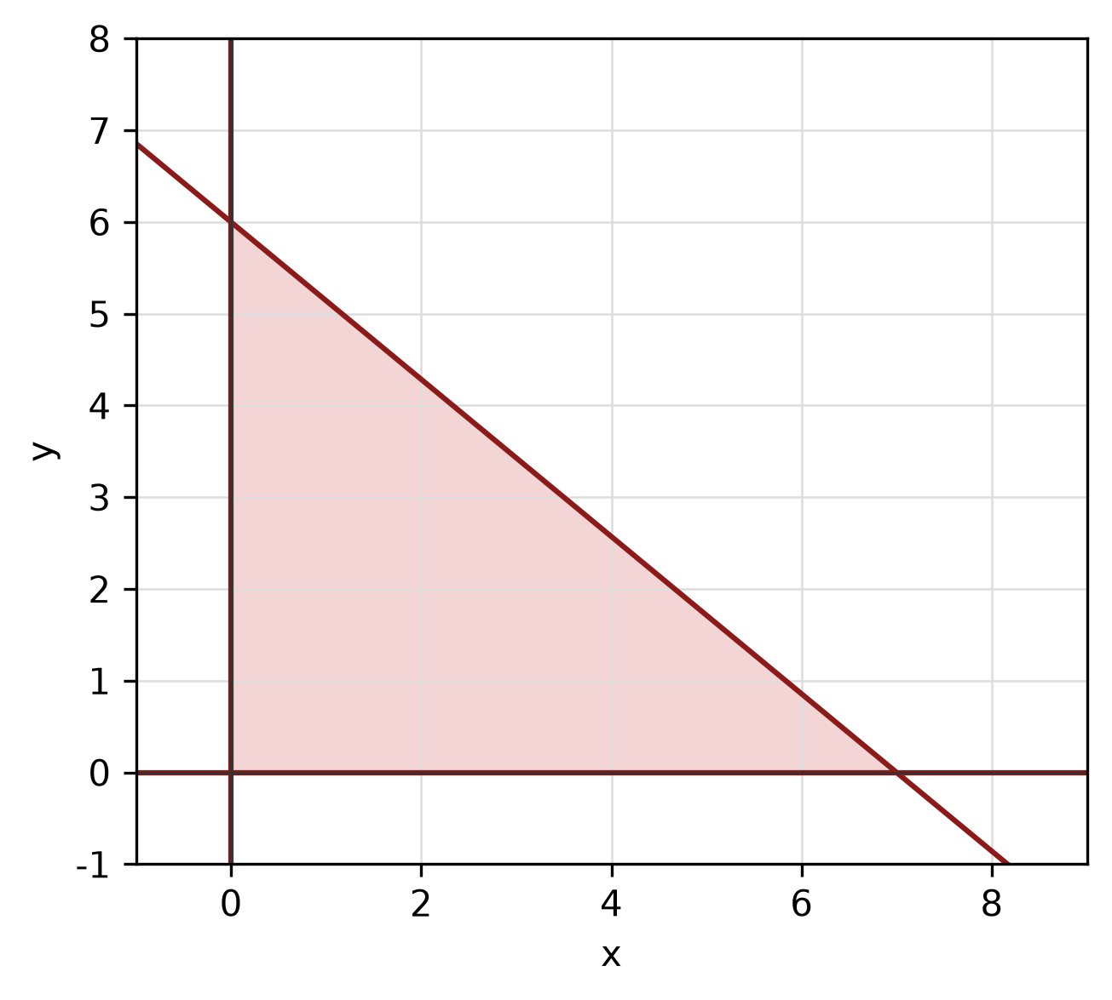
Figure: shaded triangular region.
b) Solve the simultaneous equations
-4x + y = 0
-x - 2y = 9.
(4 marks)
c) Find the standard equation of the parabola with focus (2, 7) and directrix y = 3. State its vertex.
(5 marks)
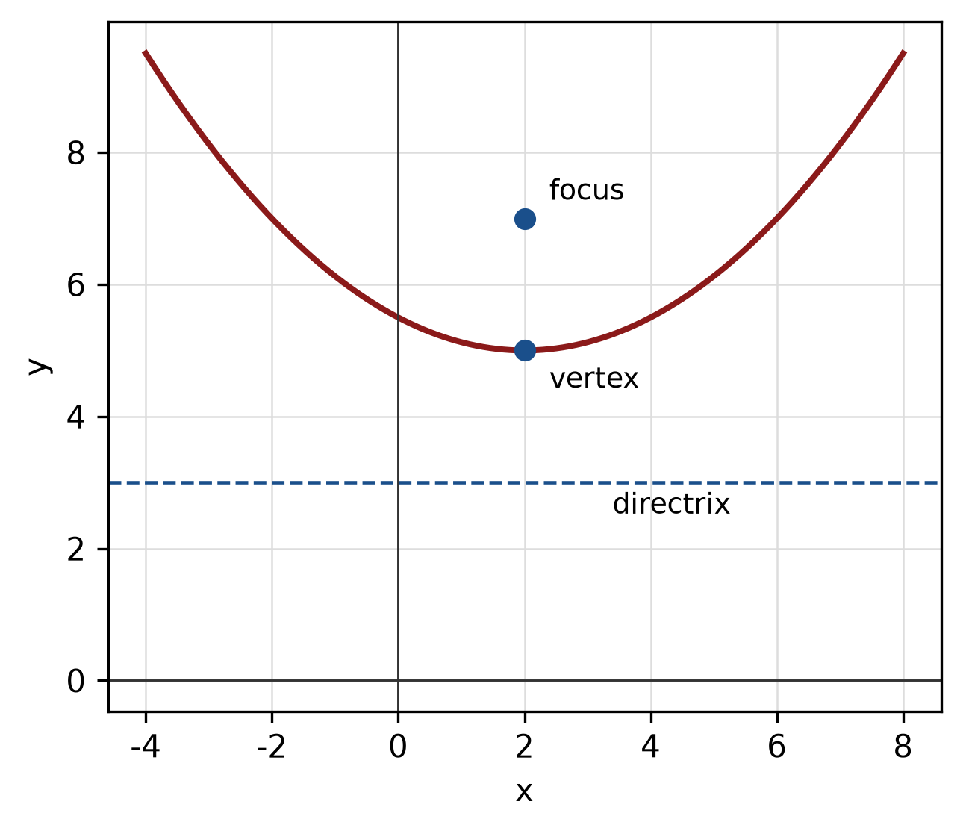
Figure: parabola with focus and directrix.
QUESTION 5
a) Given sin A = 8/17 and A is in quadrant 1, find the exact values of cos A, tan A and sec A.
(4 marks)
b) A circle has radius 8 cm. Find the length of the arc subtended by a central angle of 180°.
(4 marks)
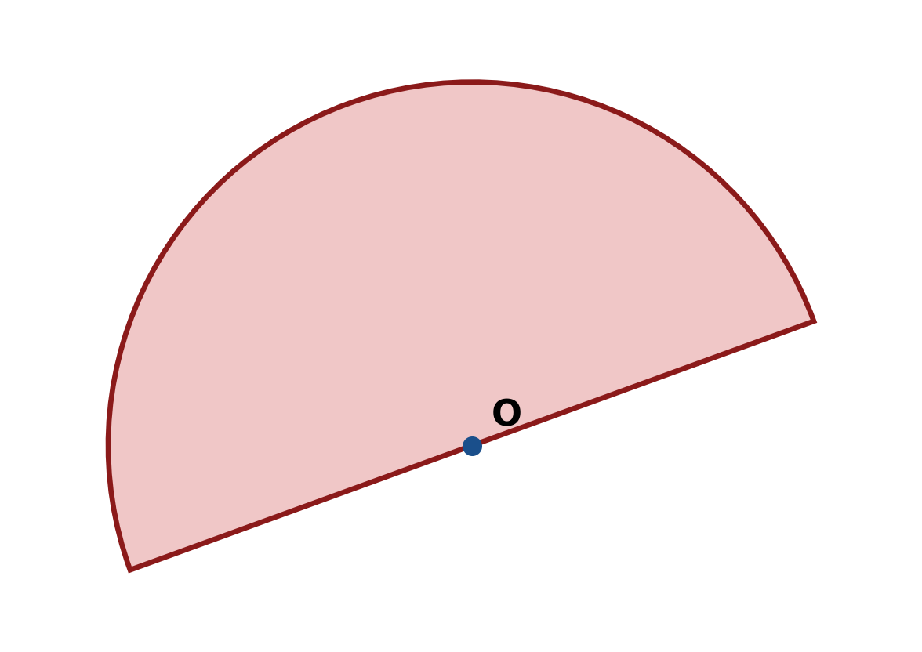
Figure: arc and sector.
c) Find the area of triangle ABC with a = 7 cm, b = 9 cm and included angle C = 90°.
(4 marks)
END OF QUESTION PAPER

APPENDIX 1
Formula sheet (as supplied with the paper).
sin² A + cos² A = 1 | tan² A + 1 = sec² A
sin(A + B) = sin A cos B + cos A sin B | tan 2A = 2 tan A / (1 − tan² A)
cos(A + B) = cos A cos B − sin A sin B | Arc length, s = rθ
tan(A − B) = (tan A − tan B) / (1 + tan A tan B) | Area of sector = ½r²θ
cos 2A = cos² A − sin² A | a / sin A = b / sin B = c / sin C
cos 2A = 1 − 2sin² A = 2cos² A − 1 | a² = b² + c² − 2bc cos A
sin 2A = 2 sin A cos A | Area of triangle = ½ab sin C

